Knights Receive Capital City Grant
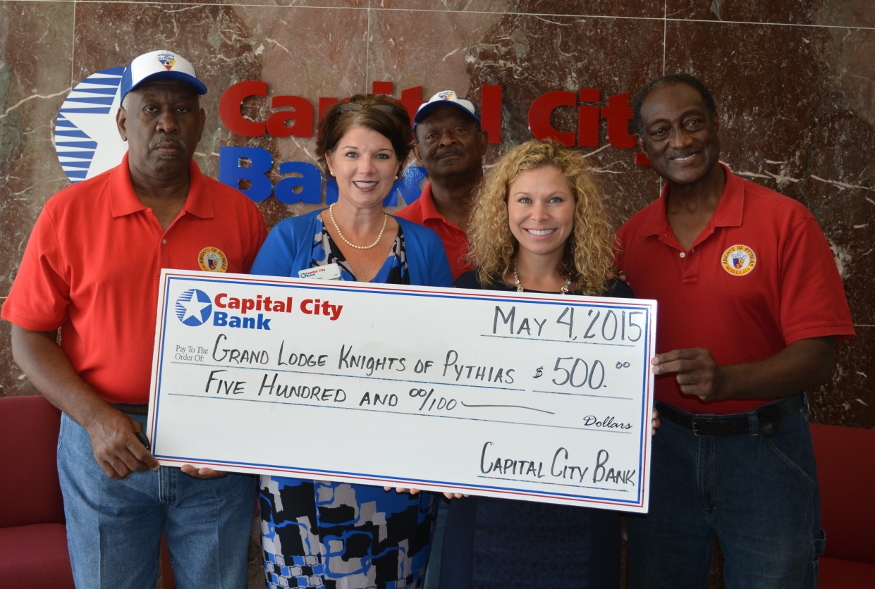
Pictured (L-R): Sir Knight George Williams, Trustee; Amy Geiger; Sir Knight David Lewis,
Master of Work; Sandy Price; Sir Knight Clarence Monette, Chancellor Commander.

Capital City Bank Group Foundation presented a $500.00 check to R.A. Driesbach, Sr. Lodge #77 / Grand Lodge Knights of Pythias , Port St. Joe, Florida Bikes for Boys and Girls Program.

The funding of this grant will be used for an expanded program of collecting new and gently used bikes for restoration/distribution and to provide a Bicycle Safety and Maintenance program for children age six to twelve (6-12). The expanded program will involve working with individuals and community groups in the City of Port St. Joe and Gulf County to collect and distribute bikes to boys and girls that would not ordinarily receive a bike. In 2014 the members of R.A. Driesbach, Sr. Lodge #77 distributed 103 new bikes to boys and girls in Port St. Joe & Wewahitchka, Fl. The plan for 2015 is to distribute 125–150 bikes to needy boys and girls in Gulf County.

The Capital City Bank Group Foundation is a non-profit organization designed to invest in those initiatives that contribute to building a strong community. The mission of the Foundation is to enhance the quality of life in the communities where they do business.

