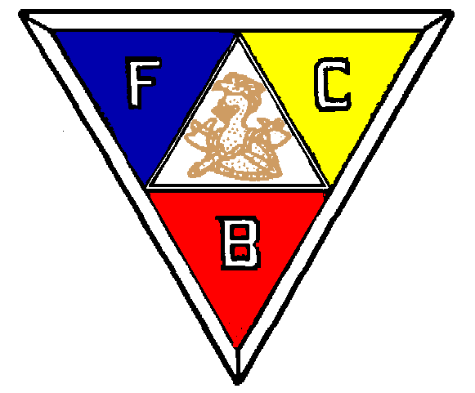
Friendship Charity & Benevolence

R.A. Driesbach, Sr. Lodge #77
P.O. Box 731 Port St. Joe, Florida 32457

March 12, 2015

Dear Friends.

R.A. Driesbach, Sr. Lodge #77, Knights of Pythias; a 501 (c) (3) Organization; organized July 18, 1929; continues to function as a catalyst for the community through a wide range of social and service projects. Your philanthropic support will be greatly appreciated.

Yes I’d like to help sponsor the following projects:

□ $ _________ Bikes for Boys and Girls - provide bikes for boys and girls in Gulf County ages 6–12 who would normally not receive a bike at Christmas.

□ $ _________ Education Scholarships - Four or more scholarships awarded each year to a graduating senior of Port St. Joe High School entering a college, university or vocational school. Applicants are considered based on their leadership abilities, extracurricular activities, scholastic achievement, community service and their exemplification of the friendship of Damon and Pythias.

□ $ _________ Historic Lodge Hall Building Restoration - Restorative project include updating electrical wiring, replacing siding, windows, doors and roof. The Knights of Pythian Lodge Hall is a central part of the Port St. Joe Community and these repairs will allow the members to continue serveing the community’s educational, social and recreational needs.

Please make checks payable to R.A. Driesbach, Sr. Lodge #77. For additional information visit our website at: www.knightsofpythiasfl.com. Or www.starfl.com.

In Friendship, Charity and Benevolence.

Clarence Monette, Chancellor Commander

Florida Solicitor # CH37281 Section 501 ( c )(3) EIN No. GRAND LODGE KNIGHTS OF PYTHIAS

